

Customer services request analysis project

Thobelani Mkhize



November 2, 2019

# importing the required libraries

import pandas as pd

import numpy as np

%matplotlib inline

# importing the datasert and ignoring the size of the memory by setting the 'low_memory = False'

custServices = pd.read_csv('311_Service_Requests_from_2010_to_Present.csv',low_memory = False)

custServices.head(5) # Showing the first five rows of the Datasert

**Output:**

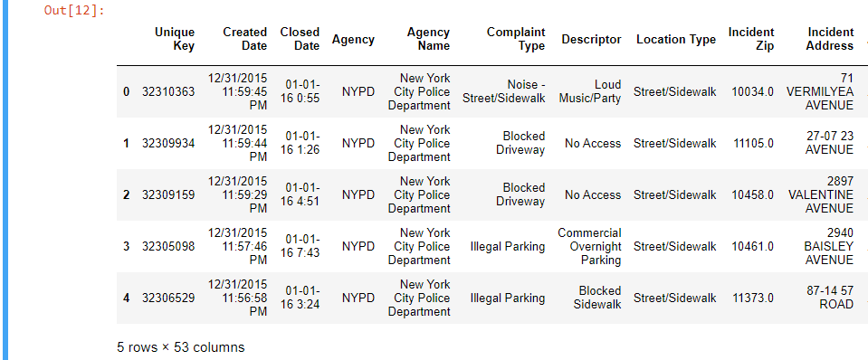

# viewing the information of the datasert

custServices.info()

**Output:**

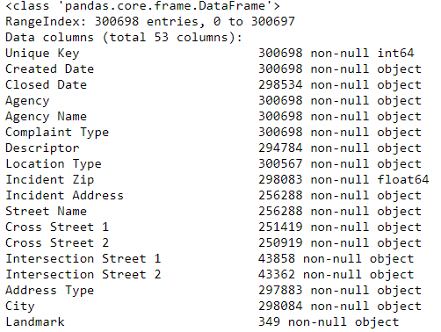

#Starting to clean the Data by droping all the null columns

nunNull_custServices = custServices.drop(["Garage Lot Name","Taxi Pick Up Location","Taxi Company Borough","Vehicle Type","School or Citywide Complaint"],axis=1)

nunNull_custServices.head()

**Output:**

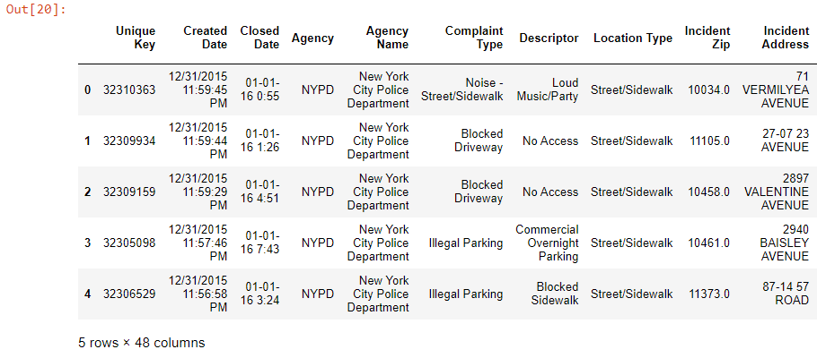

# null columns are no longer the part of the dataset, therefore the Data is clean

nunNull_custServices.describe()

**Output:**

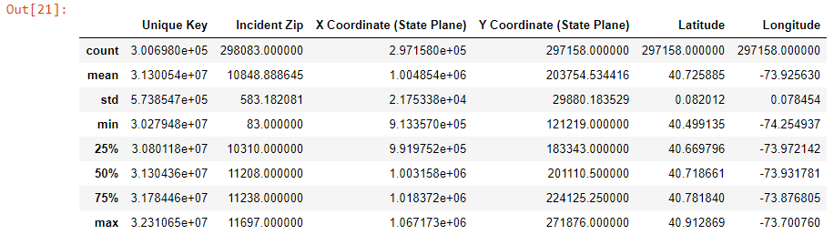

# viewing the indexis

nunNull_custServices.index.values

**Output:**



# viewing the columns

nunNull_custServices.columns.values

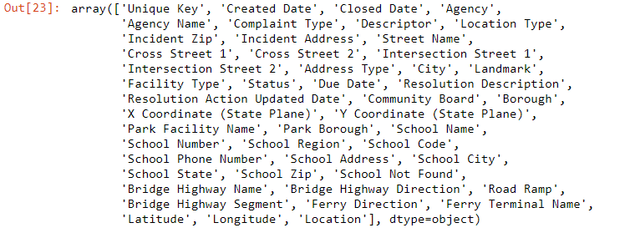

# viewing the information of the 'nunNull' dataset

nunNull_custServices.info

**Output:**

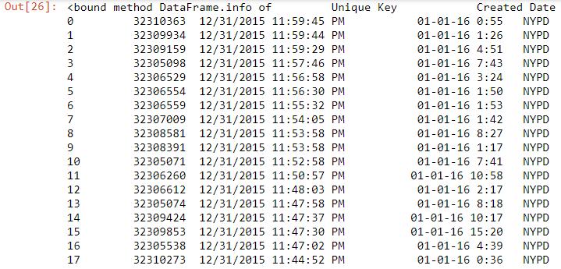

#Display the complaint type and city together

nunNull_custServices.loc[:,['Complaint Type','City']]

**Output:**

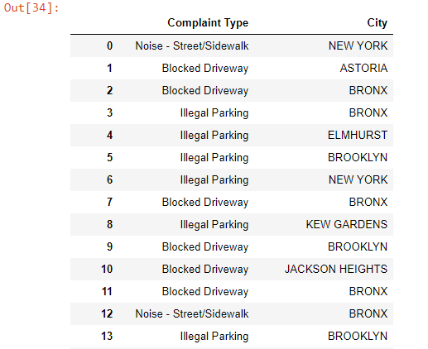

# Major insigths complaint types

majorInsightsComp = nunNull_custServices.loc[:,"Complaint Type"]

majorInsightsComp

**Output:**

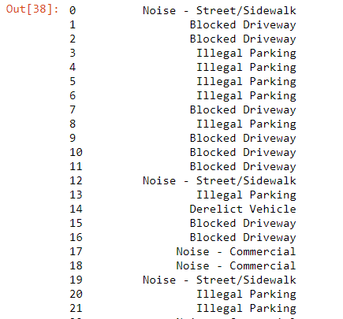

# Finding the unique major insights complaints

majorInsightsComp.unique()

**Output:**

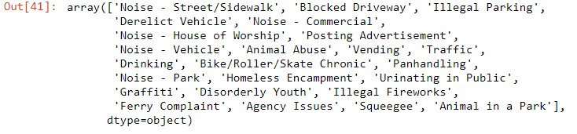

# checking the number of Unique 'MajorInsightsComp'

majorInsightsComp.nunique()

**Output:**



highComplaint = majorInsightsComp.value_counts()

highComplaint

**Output:**

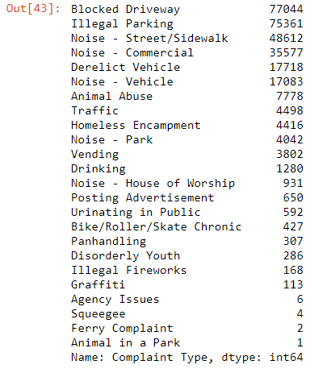

# Find the top ten complaint type

highComplaint.head(10)

**Output:**

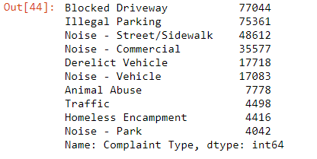

# plotting a bar graph of count with complaint types

majorInsightsComp.value_counts().plot(kind='bar',title='count vs complaint types')

**Output:**

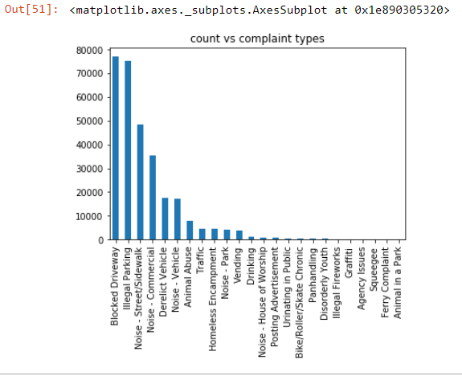

# Drawing the graph to show the Visualization of the complaint types

highComplaint.plot(kind='hist',title='Visualize the complaint types')

**Output:**

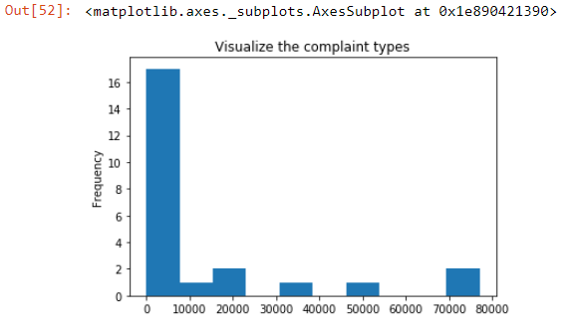

# Displaying the major Insights complaint types and their count

highComplaint.head(10).plot(kind='bar',title='The major insights complaint types and their count')

**Output:**

